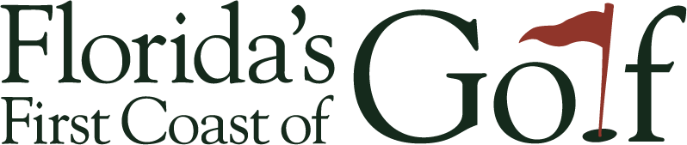

**A GOLF DESTINATION MARKETING COMPANY**

**TO:** Duval County Tourist Development Council

**FR:** David W. Reese - Florida’s First Coast of Golf, Inc.

**RE:** FY 18 Q4 Duval County TDC Report

**DATE:** August 9, 2018

1. **ADVERTISING & MARKETING UPDATES**

Continue to focus majority of advertising on top 5 markets ATL, NYC/NJ, DC, ORL, Boston and smaller amounts on CHI, Tampa, PHI, DET, Charlotte. We have Visa card holder spend top 20 markets for golf transactions in NE FL by month which will assist our decision making by market and time of year. Additional financial resources would increase bandwidth in top 5 and enable FFCG to cover markets 6-10 more adequately.  Website traffic is up 81% CYTD.

* + - Notable campaigns: Golf Channel’s Golf Advisor – August-June 2018
      1. Total Impressions = 2,601,947 | AVG CTR = 5.20%
      2. Geo targeted email open totals = 36,719 with CTR over 5%
    - Facebook Campaign Q3(Apr-Jun 2018) updates
      1. Total impressions = 1,290,138 | 10,111 clicks| .78 CTR

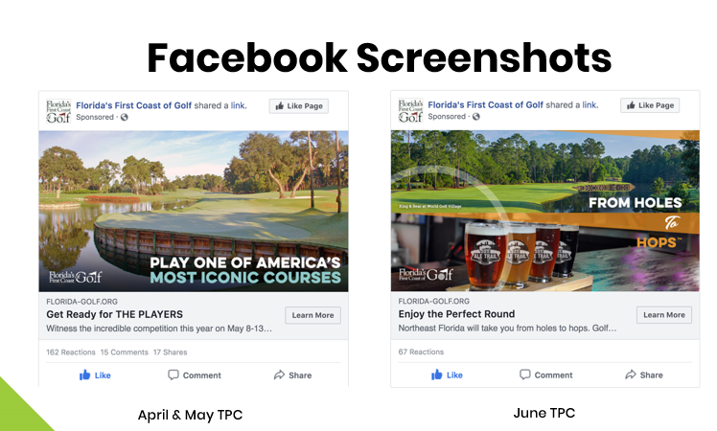

* + - Pre Roll Campaign – April - June
      1. Total Impressions – 395,039 with over 15K views
* Print Campaigns:
  1. Golf Central Magazine June 2018- Earned Media
     + Circulation 50K Print | 182K Digital
  2. GolfStyles Spring
     + Circulation 100K Print |79K Digital
* Website traffic is up 81% CYTD
* Top 5– web visitation for June
  + - States: Florida, Georgia, Massachusetts, New York, Michigan
    - Countries: US, Canada, United Kingdom, France, Spain

1. **PROMOTIONS & EARNED MEDIA REPORT**

Earned media from promotions from PLAYERS, Jaguars and special opportunities stands at $984,880 in value and 23,256,751 impressions this FY.

* 1. Visit Florida Jaguars 2018 Promotion
     + Opportunities in Nashville, New York, Houston & Indianapolis
  2. Golf Magazine China March Article | 8 pages
     + Earned Media Value= $59,208 | Impressions = 500K
  3. Golf Magazine China June Article | 4 Pages
     + Earned Media Value= $29,604 | Impressions = 500K
  4. Visit Florida PLAYERS Promotion. Philadelphia Final recap
     + Earned Media Value= $154,022 | Impressions = 2,019,333
  5. Visit Florida PLAYERS Promotion. Atlanta Final recap
     + Earned Media Value= $270,356 | Impressions = 2,663,493

1. **STATE, REGIONAL & COMPETITIVE SET ROUNDS PLAYED**



Comparisons Total Paid Rounds YTD, source- Golf Data Tech

1. **UPCOMING & OTHER ACTIVITIES**

* Attended NAC (North American Convention) – Oregon June 24-27, 2018
* Upcoming WTM London October 2018 & IGTM Slovenia December
* Hosted BET Trip May 13-18, 2018 - #1 outbound golf tour operator in China, Fujian Ez2trip/Golden Shine Holiday and a representative from each of 18 satellite affiliates across China. Bookings in our area have begun.
* Hosted editor of Golf Magazine China May 11-14th and 4 page June article was published.
* Hosted writer from GolfTime Midwest March 2018. Article to publish Fall 2018.
* Website face lift ongoing and onboarding CHUTE – social media user generated content.
* Developing new product – International Golf Fest and Pre/Post Master’s trips to pitch to international golf tour operators
* Fine tuning integration with the Visit Jacksonville Meetings & Convention Sales team. Golf part of Jacksonville’s DNA. Tournament with meeting or stay an extra day with special rate for meeting goers.
* FY 19 Funding Request